**MCA II SEMESTER**

**NAME= MADHURI SHRIMALI**

**ROLL NO = 17**

**AWS Elastic Beanstalk**

AWS Elastic Beanstalk is a fully managed service provided by Amazon Web Services (AWS) that simplifies the deployment, management, and scaling of applications. It offers a Platform as a Service (PaaS) solution that abstracts the underlying infrastructure, allowing developers to focus on writing code rather than managing servers and other infrastructure components.

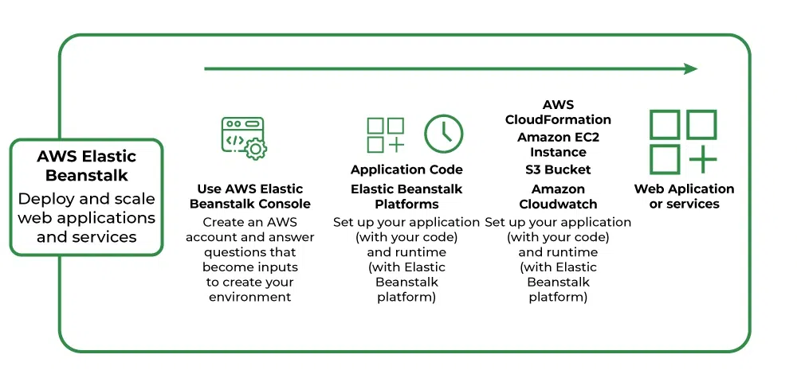

**Key Components**

1. Application: A logical container for related environments.

2. Environment: A specific deployment of an application, including resources (EC2, ELB, DBs) — either Web Server or Worker Environment.

3. Platform: Pre-configured stack (Java, .NET, Python, Ruby, etc.)

4. Configuration Files: YAML/JSON files to customize the environment.

5. Health Monitoring: Integrated with CloudWatch for metrics & alarms.

**How it Works**

1. Setup: Create application & environment.

2. Deployment: Upload code, optionally use config files.

3. Provisioning: Resources (EC2, ELB, etc.) created & configured.

4. Management: Automatic scaling & monitoring.

5. Updates: Deploy new versions with rolling updates.

6. Termination: Clean up resources.

**Features**

- Automatic Load Balancing & Auto-Scaling.

- Managed Updates & Integrated Monitoring.

- Customizable Configuration.

**Use Cases**

- Web Applications.

- APIs.

- Microservices.

- Background Jobs